## Interaction Prototyping: Heuristic Evaluation

Evaluating group: We deserve arrays

Assessed product: Event Finder by The Rolling Penguins

### Visibility of system status

In most cases, this heuristic is well implemented in the prototype. For example, the user always sees which menu section he is currently in or which day he has selected in the map view, as it is highlighted in colour. Another positive feature is that after using the Explore page, the number of new events saved is marked in colour and numerically in the menu bar. There is still room for improvement in the map view by coding the pins (e.g. with colour or numbers).

### Match between system and the real world

It has been noticed positively that all icons, concepts and wordings in the app are modelled after reality and thus could presumably also be understood well by the user without a more detailed description.

### User control and freedom

User control is given in the prototype, as one has an undo button in case one has mistakenly rejected or saved an event in the Discover page. In addition, the user can switch between the menu items at any time.

A negative point is that saved events, e.g. those that were saved some time ago, cannot be deleted from the My Events list. So once you have accepted, you can no longer cancel. However, if saving an event is not a binding commitment, then the user still does not have the option of either confirming the event or cancelling it.

### Consistency and standards

In our opinion, this heuristic is well fulfilled. In the prototype, generally accepted icons and wordings are used (although the appropriate icon could still be added to the share button, for example). The search bar also corresponds to the general standard.

The app is also consistent in itself: the same icons and words are used across the different pages. Some refinements are still necessary, however, as for example the clock next to the time on the Explore page is missing, but there is one on the My Events page.

### Error prevention

With regard to this heuristic, we did not find any noticeable negative points. Instead, we noticed positively that there were instructions for operating the Explore page to help prevent errors. However, it remains open as to when this explanation is displayed or whether one can revisit it at a later time.

Recognition rather than recall

We didn’t find any problems with this heuristic, rather some things that stood out as positive to us. The explanation for swiping on the first “Explore”-Screen helps the user to recognize which way to swipe for “yes” and “no”, rather than forcing him to recall like it works in other apps like Tinder etc.

Another positive example was that the navigation bar at the bottom doesn’t only use icons, but features text as well, again resulting in that the user doesn’t have to remember what icons have what meaning.

### Flexibility and efficiency of use

One positive thing we found was the use of swiping when deciding which events the user wants to save. This saves time and simultaneously increases the “fun-to-use”-aspect of the app.

One aspect which could be improved upon in our mind would be the personalization aspect. It wasn’t clear to us what the clickable buttons in the “favorites”-tab in the profile would change for exploring events. Would it **only** show events with those tags? Would it show them **more often** than events without these tags? This should maybe be communicated better. Furthermore, it feels like a thing that should maybe be changed in the “preferences”-tag.   
On the same note, the filter in the “explore” tab should allow the user to filter out certain event types (e.g. opera, rock concerts…). Otherwise he/she would have to put in all tags in the already mentioned “favorite”-tab except for those that he/she doesn’t want.

Aesthetic and minimalist design

We couldn’t find any problems with the design, at least in regards to it being a paper prototype. We especially liked the high signal-to-noise ratio and couldn’t find any useless information on any screen. The design also looked appealing to us.

### Help users recognize, diagnose, and recover from errors

The option to recover from errors was very well implemented with the “Undo” button. However, the user should also be able to remove saved events in the “My Events” tab to undo certain errors later on.

One further suggestion to prevent errors before they happen would be, to indicate, what decision the user makes while swiping. As an example of what we mean: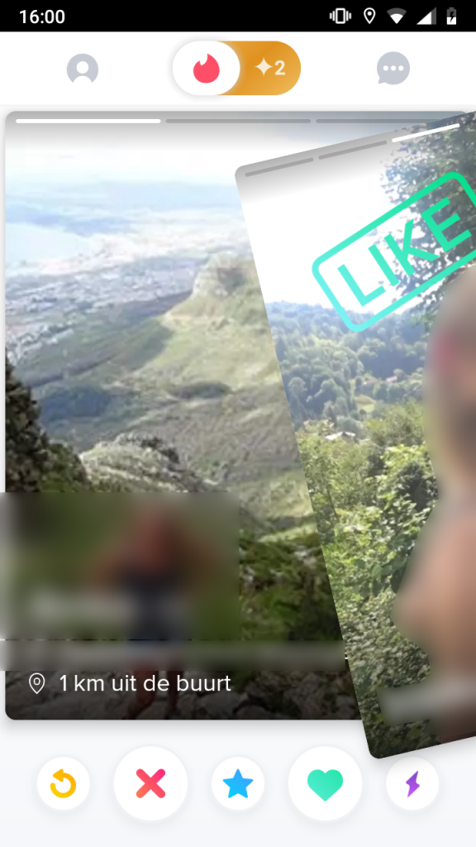

Here, the user can already see mid-swipe that he’s going to like the other person. The same could be done for the events in the EventFinder app. Some suggestions:

-Use green color for save, red color for delete.

-Use icons like a heart/floppy disc for save and e.g. a trashcan for delete.

### Help and documentation

The swiping explanation on the first screen of the “explore” tab already is a great help for the user. One further thing that could perhaps be implemented later on would be a pull event. For example: when the user does multiple incorrect inputs (e.g. clicking on the screen instead of swiping) or doesn’t give any input for a long time, the same swiping explanation could pop up.

Furthermore, there should be some kind of way for the user to find further help with issues he might have. This could be done a multitude of different ways, e.g. an FAQ, online help, documentation on “how to use”, a contact form to the creators etc.

### Further issues

There were a few other miscellaneous things that were unclear to us while using the prototype, which are listed here:

Is it also possible to book events, or just save them for your calendar? If it’s only to save them, the event creators don’t really know how many people are coming to the event, which could result in the event being hard to plan. This is of course outside of your app, but maybe something to keep in mind.

It would be nice for the user to be able to define a time span for the date in the filter. He/she shouldn’t only be able to pick a certain date (5th of November in the prototype), but maybe put in multiple days, a whole week, a whole month etc.). Another nice-to-have thing for the filter or the preferences would be to define how long the event takes (e.g. for filtering out festivals, which span a full day or multiple days).

It also is unclear what happens to events, which the user deleted. Will they never be shown again? Will they be shown again, but not as frequently? Perhaps an option to “Show all deleted events” would be nice.

For consistency’s sake and as a shortcut, the user should also be able to share events in the overview of “My Events”.

Lastly, the settings should be implemented, but that was probably planned anyways. We are guessing that things like font size, language and similar things can be adjusted there.